Clea`689 Bash tasks
1.Create one Bash script to check if a directory is available or not
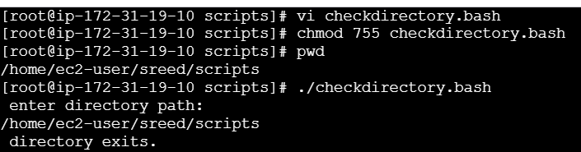
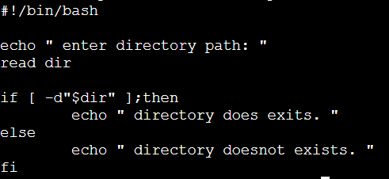
Vi checdirectory,bash – create a file
Chmod 755 checkdirectory.bash– give the permissions
./checkdirectory.bash – It shows the out of script

2. Create a Bash script which will create multiple files.
,; 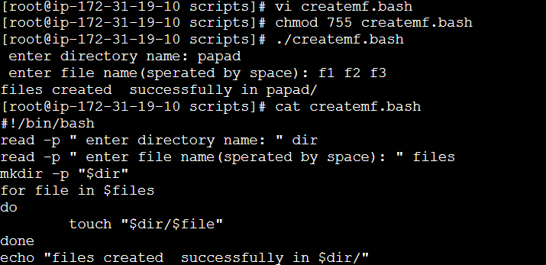
Create a file – vi createmf.bash
Using for loop condition to create multiple file
Permissions – chmod 755 createmf.bash
Output - ./createmf.bash
Check the script content – cat createmf.bash

3 .Create a bash script to take a backup of a directory.

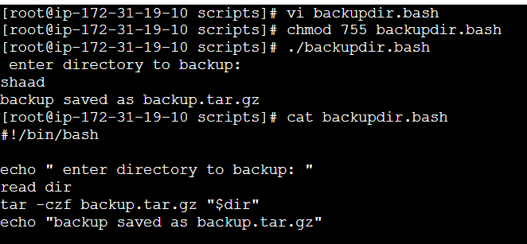
Create a file – vi backupdir.bash
tar -czf (new directory).tar.gz “$dir”

echo “(old directory )save as (newdirect).tar.gz”

4.Create a bash script to install Nginx on an EC2 server.
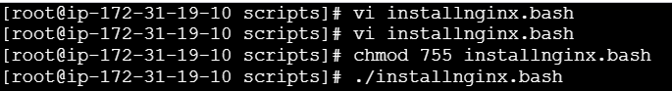
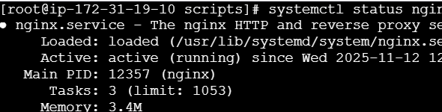
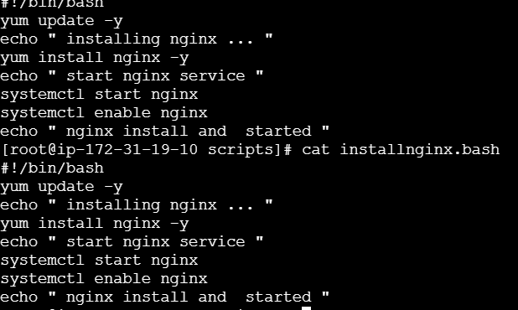
Creat a file – installnginx.bash
yum update -y
yum install nginx -y
systemctl start nginx
systemctl enable nginx
systemctl status nginx

5.Create a Bash script to install Apache Tomcat in an EC2 server. 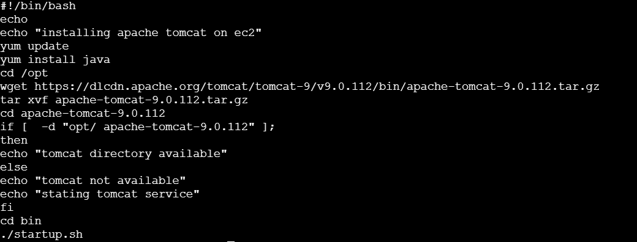

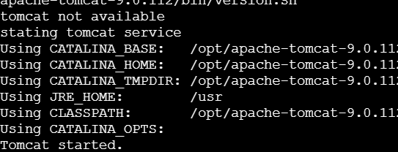
Create a file – vi apachetomcat.bash
chmod 755 - permissions
./apachetomcat.bash – to know the output
Port number check in website

6.Create a Bash script to check if a directory is available or not.If not, then create the directory.
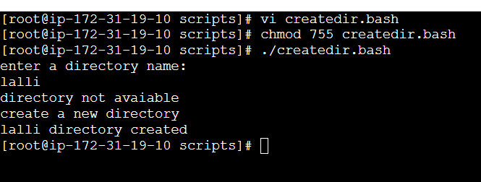
Create a file – createdir.bash
Chmod 755 createdir.bash
Cp -r / tar -cvf/xvf directory.tar.gz this command is used to compress or bundel the file

7. Create a Bash script to check if nginx service is running or not.If not running, the script should start the service.
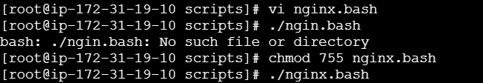
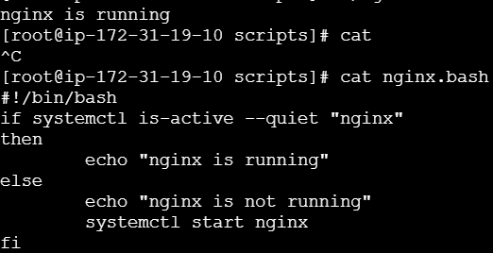
If systemctl is-active --quite “nginx” then this sytax is used to check the nginx is running or not

8.Create a bash script for a calculator.
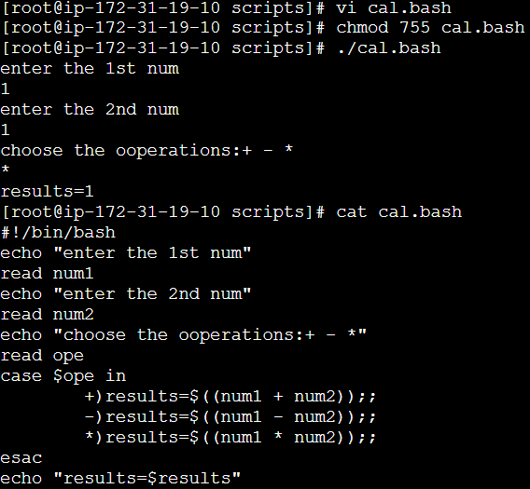
Creat a file – cal.bash
Chmod 755 -permission (chmod 755 cal.bash)
echo-display the content
operation –(-,+,%,*)
Case – check the content inside $ope

9.Create a bash script to delete the last 3 lines of a file.
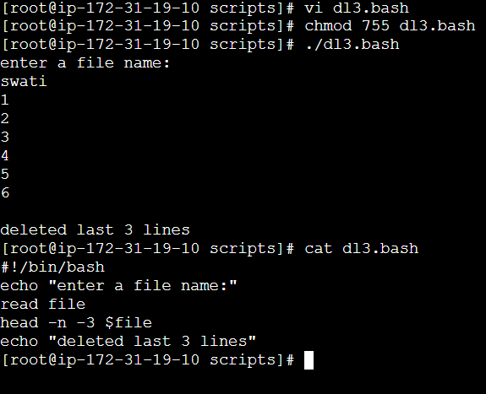
Create a file – vi dl3
Head -n -3 (file name)/ > temp.text – it will help to save the tempary file
./dl3.bash-output
10.Bash script to monitor cpu and if it is more than 80% then send email notification.
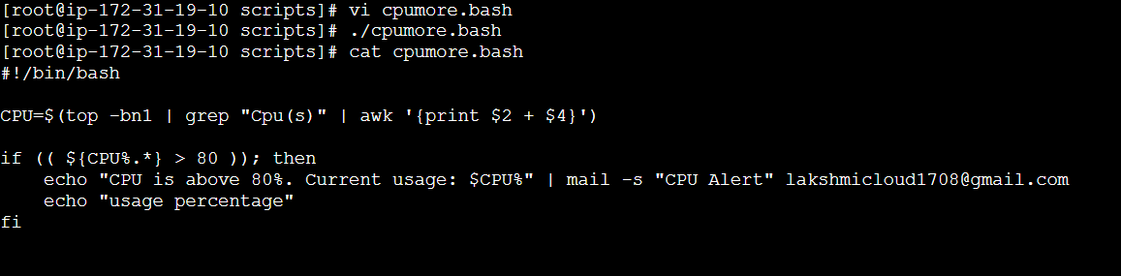
CPU=$(top -bn1 | grep "Cpu(s)" | awk '{print $2 + $4}')
Cpu = top -bni (bni use only 1 time_)
Grep “cpu(s) – use of cpu
awk '{print $2 + $4}') – to shown line by line or column
11.Bash script to monitor disk space and if it is more than 80% then send email notification.
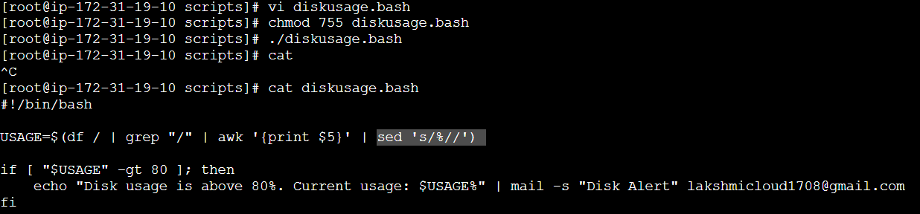
/ - root
Grep /
Awk ‘{print$5}’ – print cline by line in colum $5 means(,)colum

12.Bash script to monitor memory and if it is more than 80% then send email notification.

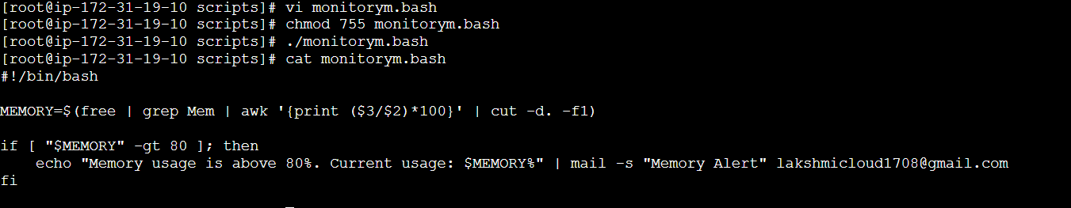
MEMORY=$(free | grep Mem | awk '{print ($3/$2)*100}' | cut -d. -f1)

